**Project Brief**

**5,000 word guide**

**Due: September 1st**

Portfolio already has:

* Class A offices
* Dominant shopping centres

Aim:

* Take on more risk through non-core locations and assets

Objective:

* Take advantage of emerging dynamic sectors
* Generate more income
* Invest this coming year

Task:

* Show how risk measured
* Show how opportunities are measured
* Give recommendations for:
  + - Locations to invest in
    - Sectors to invest in

Outcomes:

Part A:

Countries

1. Pick two countries of my choice
2. Provide brief analysis of recent performance/ trends of prime assets (office/ retail) in core locations – this will be used to benchmark and compare for later analysis

Part B:

Identify investment opportunities in:

1. Non-prime assets in core locations
2. Prime assets in secondary locations
3. Alternative real estate investment sectors

Part C:

Analysis should consider:

1. Secondary assets (office and retail) in core locations
2. Good quality assets (office and retail) in two secondary cities for each country (4 assets in total)
3. Two from the list below of alternative real estate investment opportunities (these must be the same two for both countries):

* **Leisure**:

(bars, restaurants, cinemas, theme parks, theatres, gyms, bowling alleys, spas and sport facilities)

* **Hotels:**

(budget or luxury)

* **Institutional grade residential**

(build to rent BTR and senior housing)

* **Student accommodation**
* **Healthcare**

Part D:

1. Interpret risk for the sector/ location
2. Interpret opportunities for the sector/ location
3. Analyse the fundamentals **(market drivers)** underlying the markers AND real estate types
4. Support analysis with price information
5. If analysis says it is not worth taking on the risk in the countries it is IMPORTANT to argue the case well and say why it is better to stick to core
6. Highlight sectors that have the potential to become mainstream investor sectors in the near future (client will appreciate non-conventional recommendations)

Assessment criteria:

- Evidence of research

- Evidence of understanding market fundamentals and assessment of opportunities and risks

- Comparative analysis

- Clarity of argument

– use section summaries

– SWOT (Strengths, Weaknesses, Opportunities and Threats) analysis for comparing investment strategies

– tables etc.

- Convincing, well-developed professional recommendations

Canada

South Africa

Seychelles

Saudi Arabia

* Chosen countries as variation in GDP world ranking according to (World Population Review, 2019)
  + Canada = 10
  + South Africa = 36
  + Saudi Arabia = 20

**How to manage risk in real estate investment (Parsley, 2018)**

* **Larger mega-themes (things not related to economic cycles)** 
  + Student houses
  + PRS (private rental sector)
  + BTR (build to rent)
  + Micro living
  + Co-working concept
* Long term income
  + Hotels
  + Student accommodation
* Industrial sector has been improving over the past 12 months
  + Investors think they will see future rental growth
  + Yields have fallen
* Bulk good stores are still doing well such as lidl and aldi
* Key issues for managing risk:
  + Focus on centres where people:
    - Work
    - Play
    - Live
    - Learn
  + Capital preservation
  + Pre-let 25% to make sure theres income
  + Real time reporting to help preserve capital and maximise returns

**Risk**

* Value at Risk (VaR)
* Beta
* Standard deviation
* Systematic risk management
  + Associated with the market
  + Mitigated through hedging

**Project**

* Market analysis
  + Why invest in these countries
  + Ease of doing business.

**Investment philosophy**

* **Diversification** 
  + Different continents
  + Investing globally can hedge against currency risks
  + Prospectively improve overall returns
  + One G7 country (Canada)
  + Saudi Arabia
  + Mongolia (14th fastest GDP growth)
  + Active management to improve investment outcomes

**Country selection process**

* Based on growth prospects
* Long term investments (held for at least 5 years)
* Diverse portfolio to minimise risk

[**http://cbre.vo.llnwd.net/grgservices/secure/2019%20CBRE%20POOC_Q9bx.pdf?e=1562945116&h=3e972b3d64247a3b2e51214eca4bffe0**](http://cbre.vo.llnwd.net/grgservices/secure/2019%20CBRE%20POOC_Q9bx.pdf?e=1562945116&h=3e972b3d64247a3b2e51214eca4bffe0)

selecting a country

* Could do china and pick hema saving retail
* Seoul

**SAUDI ARABIA NOTES**

(Majdalani, 2019)

* GDP is set to continue rising
* Average growth of 2.2% GDP in the next five years
* Lack of high quality stock therefore key office schemes continue to out perform the market
* Hospitality market its forecasted to increase in popularity
* Rental trends have decreased

**Reasons to invest globally**

(Bhalsod, 2018)

* Benefits of going global:
  + Risk reduction
  + Return enhancement
* **The 4 main benefits of adopting a global approach** 
  + **Diversification of macro and property market risk**
  + **Improve risk-adjusted retuns allowing targeting of an income return**
  + **Opportunity to target strategic timing of international property cycles**
  + **Access to a large and more diverse opportunity set**

**1) look at what the portfolio already has and question if it has liquidity risks/ economic stability risk/ economic resilience/ economic stability/ financial risk/ external risk/ political risk/ transparency/ liquidity/ volatility**

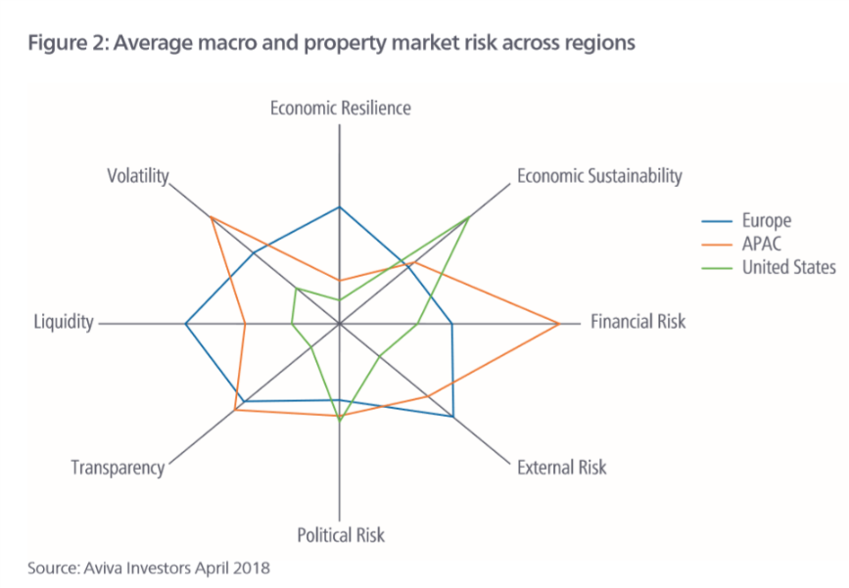

**Concordance in Global office Market cycles**

(Alexy Akimov, 2014)

* D’Arcy et al., 1997 shows the importance of economic fundamentals in determination of both retail and capital values
* **Conner & Liany (2005) shows** the average correlation between US stock market and foreign markets is 0.7. the average US GDP is only 0.19 ; therefore fund manager should diversify globally
* **Harding & Pagan (2006) the measure used BBQ method**

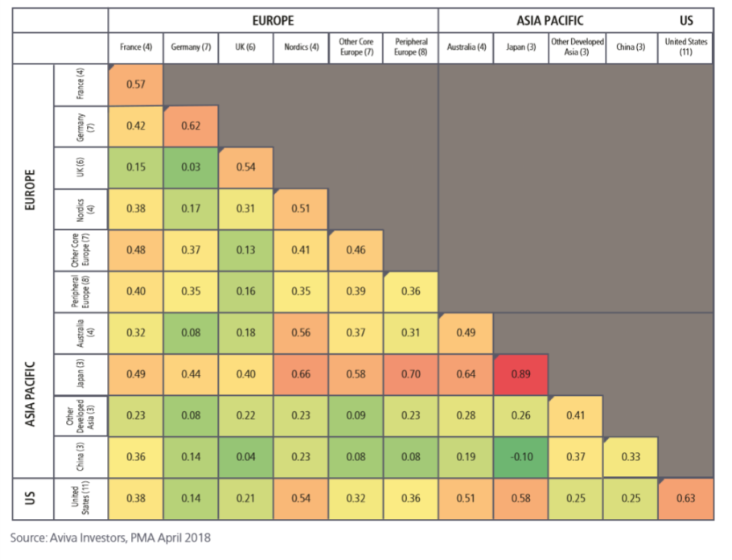

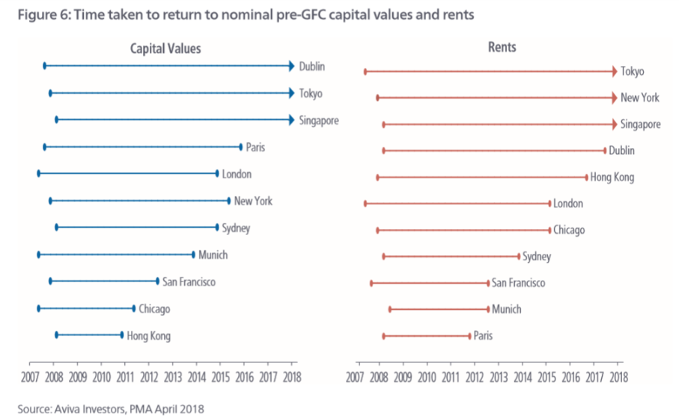

* **I think the aim is we want:** 
  + **Two countries that show concordance**
  + **Diversified via continent**
  + **Different economic cycles**
  + **One developing world country as “ it is expected that they will experience a much faster growth in investable stock that mature markets”**
  + **Look for the JLL transparency scores**
  + **Look to invest using different types of capital**
  + **Cyclical approach through active management**
  + **Four quadrant approach** 
    - **Further diversification via** 
      * **Size of building costs of buildings**

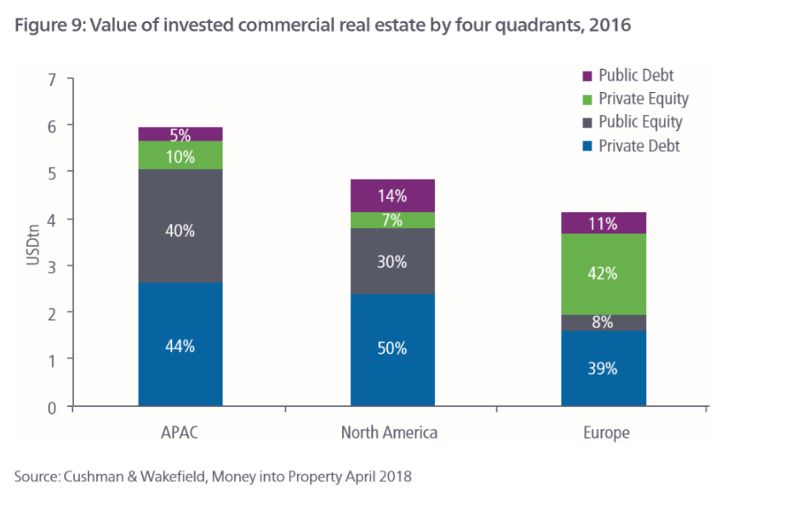

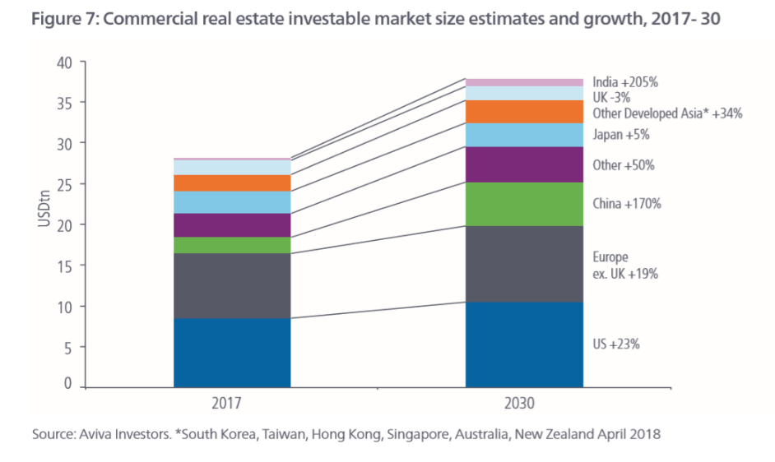

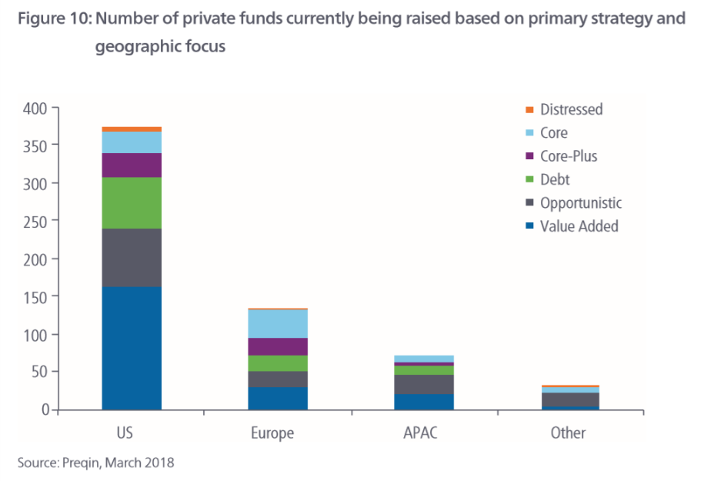

**Improving real estate performance through global diversification**

(Standard, 2019)

* Take advantage of mispring in core, non-domestic markets
* Indirect for smaller firms
* Direct investment for bigger firms
* **Things to consider:**
  + **Taxes**
  + **Fees**
  + **Currency**
  + **Leverage**
  + **Risk**
* Currency hedging to avoid currency fluctuations
* Diversifying allows access to some sectors that are otherwise not allowed in certain countries as well as strategy opportunities
  + Student accommodation
    - * + Both /\\/ have grown the most in recent years
  + Retirement homes
* 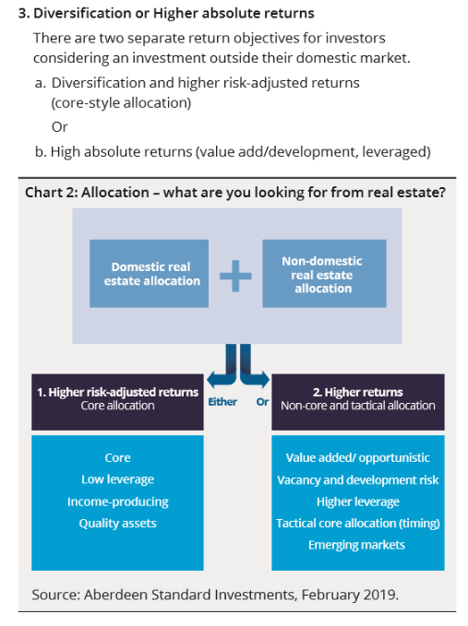
* 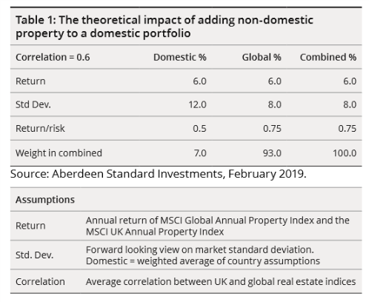
* **Look for asset specific risks:** 
  + Location
  + Sector
  + Tenant
  + Buildings
* Higher unequal lot sizes means higher number of assets to reduce the risk
* 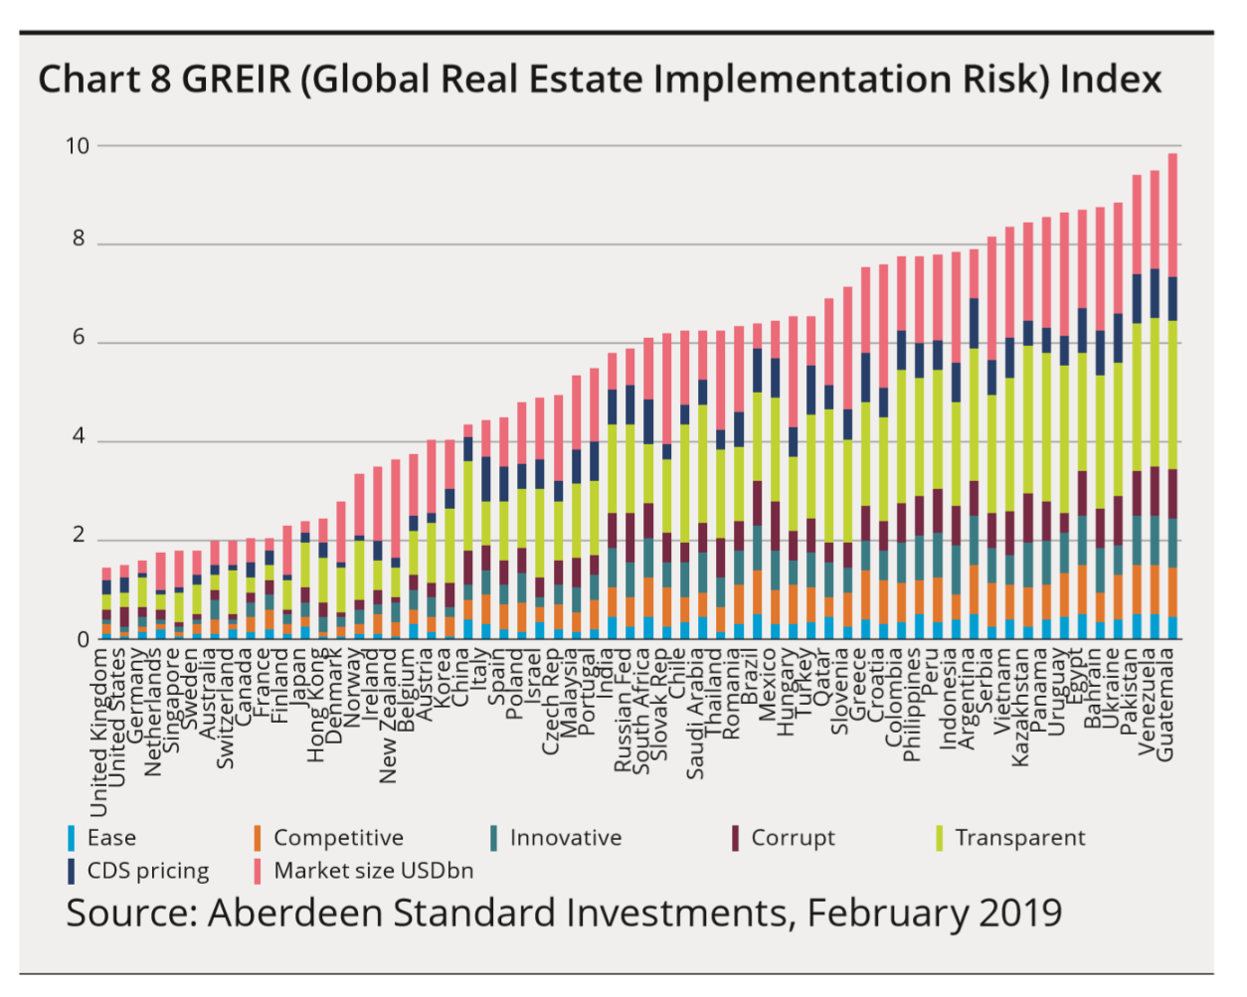Look for REITs/ unlisted real estate funds and funds of funds
* https://www.prsgroup.com/regional-political-risk-index-4/ **Asian political risk source**
* Looking at different types of capital investment opportunities
* Active management
* Using a developing world country as “it is expected that they will experience a much faster growth in investable stock than mature markets”
* Size of buildings
* Use of buildings

Other things considered included

* Taxes
* Fees
* Currency
* Leverage